ITPV302 FINAL DOCUMENTATION

PROJECT NAME

STUDENT NUMBER(S)

STUDENT NAME(S) AND SURNAME(S)

Table of Contents
1. Business case 1
1.1 The problem 1
1.2 Project objectives 1
1.3 Problem background 1
1.4 Related systems analysis 2
1.5 The project plan 3
1.6 Risk Analysis 4
2. System Requirements 6
Specifications and Technical Design 6
2.1 Plan to Address Objectives 6
2.2 Project scope 7
2.2.1 Information scope 7
2.2.2 Functional scope 7
2.2.3 Communication scope 7
2.3 Business requirements 7
2.4 Hardware and Software Requirements 8
2.4.1 Software Requirements 8
2.4.2 Hardware Requirements 8
2.5 Design constraints 8
2.5.1 Security constraints 8
2.5.2 Interface constraints 9
2.5.3 Performance constraints 9
2.6 High-level use case diagram 9
2.7 UML Class Model / Diagram 10
2.8 Relational Database Model Diagram 10
2.9 User Interface Design 11
3. Implementation 13
3.1 Choice of Tools 13
3.1.1 Visual Studio 2017 13
3.1.2 SQL Server 2015 13
3.2 Extracts of complex code 13
3.3 Source code references (if applicable) 14
3.3.1 Converting images to byte arrays 14
3.4 Problems encountered 14
3.4.1 Creating a WCF web service 15
4. Conclusion 16
References 17
A. Business case revisions 18
A.1 Changes made in response to comments 18
A.1.1 Justify (align) document text 18
A.2 Changes made as the project progressed 18
A.2.1 Changed objectives 18
B. System requirements, specifications and technical design revisions 19
B.1 Changes made in response to comments 19
B.1.1 Changes to ERD 19
B.2 Changes made as the project progressed 19
B.2.1 Extra feature added 19
C. Implementation revisions 20
C.1 Changes made in response to comments 20
C.1.1 Extract of complex code was boilerplate 20
C.2 Changes made as the project progressed 20
C.2.1 Added a problem encountered 20

1. Business case

The introduction starts with describing the purpose of this document and what it will cover.

1.1 The problem

The heading above is just a placeholder. You need to provide a heading which draws attention to your actual problem, e.g. “Healthcare worker patient notes”. This section should provide a general description of the problem you are addressing. Include information such as:
- What the problem is – not the lack of software, but what is the actual real-world problem that you can help solve by providing software.
- The domain of the problem (i.e. where it takes place)
- Who is encountering the problem?

Be as descriptive as you can. Think about how much information you will provide a possible financial backer to make them care about the problem and make an investment.

1.2 Project objectives

In this section you should list the real-world problem issues that your software intervention will address, e.g.:
- Replace the paper-based note-taking system used by healthcare workers with a digital alternative.
- Ensure that notes cannot get lost, by providing an off-line saving system.
- Provide a central means by which to search through historic notes.

Think of these as the main things that your system will do to address the real-world issue.

1.3 Problem background

This is the literature review section of the document. In order for reader to better understand the problem, this section must provide an overview of the problem area using existing sources, e.g. web references, conference papers, white papers, patents or journal articles. You are required to use proper APA referencing. The idea with this section is that if a reader has no knowledge of the real-world problem area; this section should provide them enough background to understand the issue, e.g. an overview of the process that healthcare workers use when visiting patients in remote areas.

1.4 Related systems analysis

You are required to find (at least) 3 software-based systems which address the same issue as the one addressed by your proposed system or systems which use a similar process to what you envision for your system.

For each related system you are required to provide the following:
- The name of the system
- Platform (e.g. web, Windows / Mac, Android / IOS, etc)
- Description of the system
- At least one screenshot. All screenshots must have properly numbered and worded captions. The text in your document must explicitly refer to it, e.g. Figure 1.1 demonstrates the login screen of System X.
- A list of features / processes that you would like to adapt and incorporate into your system (i.e. the reasons why this system caught your eye)
- A list of features / processes that you would like to avoid in your system.
- Each related system should be properly referenced.


This Photo by Unknown Author is licensed under CC BY-NC-ND
Figure 1.1 System X Login Screen (Author, 2022)

1.5 The project plan
A project, or project management plan is a document that contains a project scope and objective. Typically, it will be represented as a Gannt chart to make it easy to convey information.
A project plan should answer these questions:
- What are we delivering?
- How will we deliver on time?
- Who is working on the project and in what role?
- What miles stones/goals are set for project?
Before you can start your project plan you need to understand (at a minimum) the following things:
- What does your client expect/need?
- The goals of the project
- What is the decision-making process of your client, and how will they approve and review the project work?
- Who is the sponsor?
- Who is the project manager?
- What other stakeholders are important?
As project manager you also need clarity from your client to know exactly what their expectations are. Sometimes this requires you to ask some hard questions to get a clear understanding.
Questions that may impact a project plan:
- How will you collect feedback?
- Who has the final sign-off?
- What is the project deadline?
- What is the availability of the project team?
- How often will the teams meet for feedback?
- Does your team have a history of successful projects?
- What can prevent the project from being a success?
- What tools and methods of communication will the team use?
Your project plan should include the following information (at the very minimum):
- Project and client name (make one up)
- Delivery date and version
- Milestones and deliverables
- Clear task durations with start and end dates (using a Gantt chart)
- Dependencies for tasks (i.e., should anything happen before this task can happen).

1.6 Risk Analysis

A risk can be defined as an unexpected event or condition, which can impact negatively on the entire project. Some will argue that the event or condition can also affect the project in a positive way.
There are many models, which are used to identify different risks. But we will not go into specific ones here. In general, we can say that to categorise risks can help in the process. You will quickly discover that you need to limit yourself regarding risks during a brainstorming activity. Otherwise, the list of events and conditions can become very long. You need to assess how likely it is that the particular event occurs. For instance: The entire project could be ruined if a woman in labour runs across a road and a driver has to swerve to avoid her. The driver crashes into a bus and loses a wheel, which rolls across the road, pulls along a bag of dynamite, which was about to be used. The dynamite then explodes next to a lamppost, which shoots, like a rocket, through the window of the project teams office. The rocket hits the project leader in the head and the project leader, by mistake, deletes all the code, which has been written. The rocket continues through the office and finally lands on a shelf filled with super magnets, which then fall onto the server, which contains all the backups and removes them all. But how likely is this?
Once you have identified the risks, you need to decide how you will handle those risks. It is a good idea to divide the risks into four main categories:
Acceptable risks: We decide that the risk is very unlikely, or possibly, that the costs if that event happens, are lower than the expenses which are necessary to prevent the event from taking place.
Avoidable risks: We take action which ensures that we prevent a certain event or condition. We might create backups of all the code and store it in two separate locations. Then we avoid the risk of losing anything,
Minimizable risks: We take steps to ensure that the likelihood of something happening is less. We can create a bonus structure to make sure that people do not leave.
Transferable risks: This means that we transfer the risk to someone else. For example, we might send part of the work to another company. Then it is the other company, which needs to assume the risk. Once we have categorised all the risks, we need to decide exactly what needs to be done, if something should be done. We need to prepare ourselves as best we can so that any potential events have as little impact on the project as possible. We can, of course, have free fruit available at work and encourage everyone to exercise regularly. But someone will get sick in any case and then it is great to know how we handle that. Who is going to take over the sick person's work? When is it necessary for someone to step in? Should the person step in be someone in the team or someone from outside the team? In the case of the latter, where should the person be brought in from? How much will this cost?
Identify (at least) 4 risks to your project. If you have time, add more, since the more you are able to identify at the start, the better you can plan for things to go wrong (and they usually do). For each risk, state which type of risk it is and how you will treat/handle the risk.

2. System Requirements

Specifications and Technical Design

The introduction starts with describing the purpose of this document and what it will cover.

2.1 Plan to Address Objectives

In your business case you specified a few objectives. These were real-world issues that your software intervention will address. In this section you need to stipulate what you will do in your software to address these objectives. E.g. the following objectives were stated in the business case:

- Replace the paper-based note-taking system used by healthcare workers with a digital alternative.
- Ensure that notes cannot get lost, by providing an off-line saving system.
- Provide a central means by which to search through historic notes.

These objectives can then be discussed as follows in this section:

In order to the replace the paper-based note-taking system used by healthcare workers, an Android-based mobile application will be developed. Android was chosen as it is the most widely used mobile operating system under the target group of healthcare workers. A mobile application will ensure that the healthcare workers have access to the system wherever they may be working from on any given day.

Because of the mobile nature of the work of these healthcare workers, they frequently lose their notes. A mobile application will be able to address this issue by saving the notes on the device itself. Since the healthcare workers may be travelling in areas with little or no access to network connectivity, it is essential to save offline copies of any notes made. Whenever the healthcare worker moves into an area with connectivity, the local notes will sync to a central server. This also ensures that if a healthcare worker loses their phone, they do not lose their notes.

Currently, if a healthcare worker needs to search through their notes, they need to search through a stack of papers. If they need to give their manager access to their notes, it involves the manager rummaging through the same stack of notes. A digital application will allow the notes to be easily searchable through a web-based interface. A web-based interface was chosen for this aspect of the solution as the healthcare workers frequently check their notes only when they are back in the office. This also allows the office-bound managers to easily access the notes of individual healthcare workers to search for trends.

2.2 Project scope

The scope must provide a high level view of data requirements. This should include a discussion on the information, functional and communication scope of the intended system. The scope of a project is very important as it sets the expectations of the project. Be realistic when setting your scope.

2.2.1 Information scope

In this section, discuss any details regarding the storage and handling of information, e.g. what will be stored, where will it be stored (on device or elsewhere) and will it be encrypted?

2.2.2 Functional scope

In this section, discuss the feature which you plan to include in the system, e.g. capturing of notes on a mobile device, searching through notes by a web interface and generating reports.

2.2.3 Communication scope

In this section, discuss how communication will take place with the system, e.g. will the system send SMSs, will it notify the healthcare worker that they are offline or that the system has synced, will it work over mobile connections or just Wi-Fi.

2.3 Business requirements

Business requirements, also known as stakeholder requirements specifications (StRS), describe the characteristics of a proposed system from the viewpoint of the system's end user. In this case, the system has two end-user types, namely healthcare workers and managers. These two user types might have different needs from the system, e.g.:

Healthcare workers require a system that is dependable and always available. It should have an easy-to-use interface to facilitate simplified note taking while the Healthcare workers are travelling.

Managers require centralized access to the notes of the healthcare workers. The search interface should be clutter free and allow notes to be searchable according to key words and filtered according to date ranges.

2.4 Hardware and Software Requirements

State which hardware and software tools will be used both in developing the application and in its use, e.g:

2.4.1 Software Requirements

- The mobile application will be developed using Android Studio.
- The web application will be developed using Microsoft Visual Studio 2019.
- The mobile application will use Sqlite as its local storage medium.
- Microsoft SQL Server 2017 will be used as the shared online database.
- Connectivity between the app, the web interface and the shared database will be facilitated by developing a WCF Web service in Microsoft Visual Studio 2019.
- The mobile application requires a phone running (at least) Android 2.3 (Gingerbread).
- The web application will run in any browser but will be optimized for Google Chrome.

2.4.2 Hardware Requirements

- The mobile application requires a mobile phone with at least 1Gb or RAM, capable of running Android 2.3.
- The web application may be opened on any device with a web browser.
- The web application and SQL Server will be hosted on a shared web server.

2.5 Design constraints

In this section, discuss any constraints that there might be on the system development and / or deployment process. This can include things such as security, interface and performance constraints.

2.5.1 Security constraints

Discuss any issues related to the security of the proposed system, e.g.

The notes taken by the healthcare workers might be of a sensitive nature, as they contain information regarding patients seen by the healthcare workers. Therefore, care must be taken to encrypt the notes both on the phone and the server and to ensure that users should provide a username and password when accessing the system. The username and password should also be encrypted.

2.5.2 Interface constraints

Discuss any issue related to the interface of the proposed system, e.g.

The mobile interface needs to be user-friendly as it may be used by health care workers who are not technically savvy. The web interface should be responsive so that users have the choice to view the pages on a desktop, tablet or phone.

2.5.3 Performance constraints

The system should be optimized to ensure that searches through the web interface are fast and efficient. The mobile application should be optimized for use on low end mobile devices with low memory capacity and older processors.

2.6 High-level use case diagram

The purpose of a use case diagram in UML is to demonstrate the different ways that a user might interact with a system. A use case diagram can summarize the details of your system's users (also known as actors) and their interactions with the system.

Example:

Figure 1.1 presents a high-level use case diagram of the proposed system and its users.

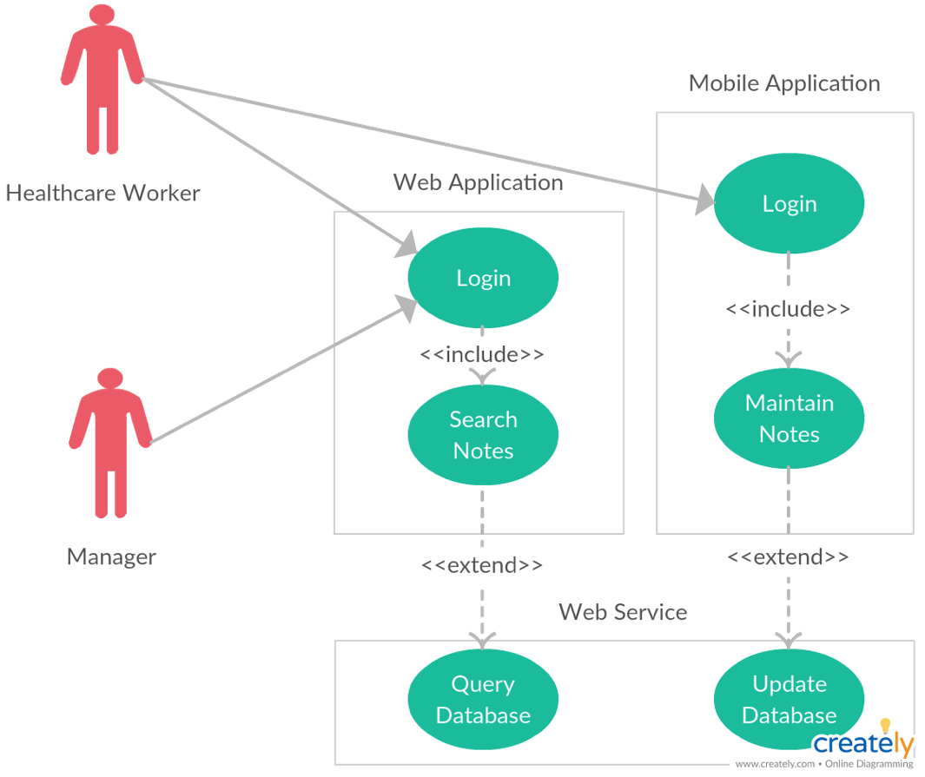
Figure 1.1 High-level use case diagram

2.7 UML Class Model / Diagram

This section should present your (planned) UML class model. If you have not yet started your system development, you may draw the diagram using a stand-alone tool, such as Visio. Alternatively, if you have already started development, you may use the class diagram created for you by tools such as Visual Studio. This does not need to be the final version of your UML class model as you’ll be able to update the diagram in your final, combined report at the end of the semester. The number of classes in your diagram tends to align with the number of tables in your database.

Example:

Figure 1.2 represents the UML class diagram of the YOURPLANNEDSYSTEMNAME system.

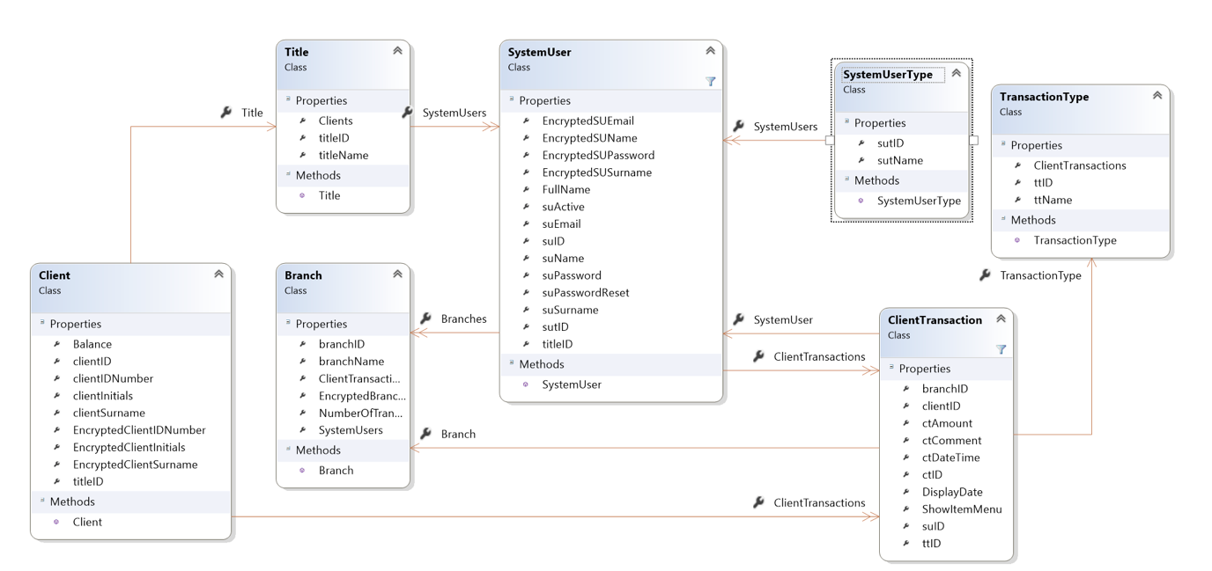
Figure 1.2 UML Class Diagram

2.8 Relational Database Model Diagram

This section should present the (planned) version of your relational database model. If you have not yet started designing your database, you may draw the diagram using a stand-alone tool, such as Visio. Alternatively, if you have already started the design, you may use the ERD created for you by tools such as SQL Server Management Studio. This does not need to be the final version of your relational database model as you’ll be able to update the diagram in your final, combined report at the end of the semester. Remember, it needs to have the absolute minimum of the equivalent of 10 tables. Groups of three students will need at least 14 tables.

Example:

Figure 1.3 represents the entity relationship diagram of the YOURPLANNEDSYSTEMNAME system.

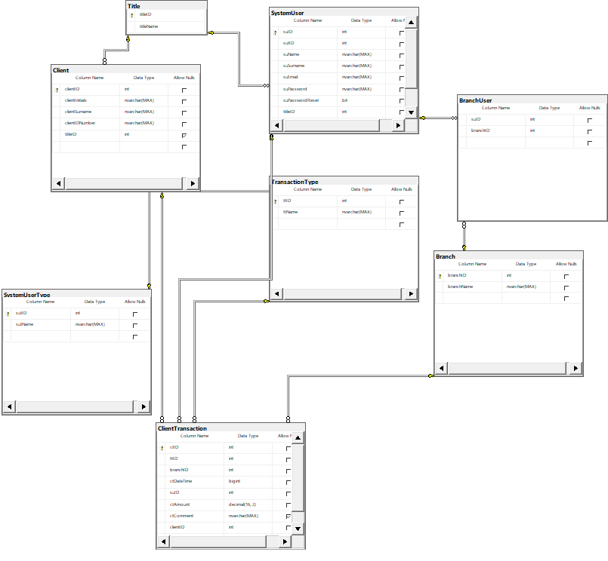
Figure 1.3 ER Diagram

2.9 User Interface Design

This section should present the user interface designs of at least 8 screens from your proposed system (10 for groups of 3). If you have not yet started on your system development, you may use stand-alone tools such as Visio to create simple versions of your planned screens. These can be in the form of low fidelity wireframes. Alternatively, if you have already started system development, you may take screenshots of the screens you have already completed. For each screen you are required to provide a description of the functionality. These do not need to be the final versions of these screens as you’ll be able to update the screens in the final, combined report at the end of the semester.

Example:

Figure 1.4 represents the login screen of the YOURPLANNEDSYSTEMNAME system. The screen requires that a user enter their email address (as a username) and a password. Upon successful login, the user will be redirected to the system’s landing page. The screen also provides the user with an option to use in the event that they have forgotten their password.

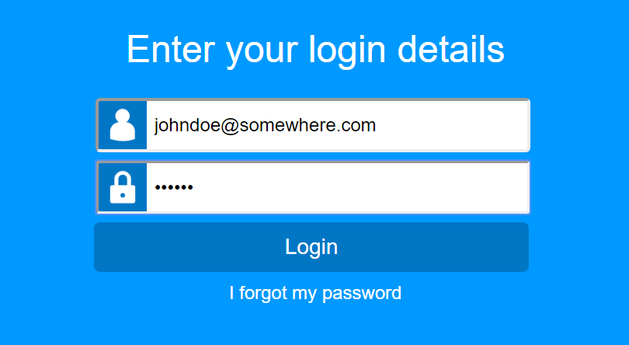

Figure 1.4 Login Screen

3. Implementation

The introduction starts with describing the purpose of this document and what it will cover.

  - Choice of Tools

In this section you should describe the tools you used to develop the application and why the specific choices were made, e.g. Visual Studio 2017, SQL Server 2015, etc. In each case use the name of the tool as a numbered sub-heading.

    - Visual Studio 2017

Discussion here.

    - SQL Server 2015

Discussion here.

3.2 Extracts of complex code

This section should present extracts of code which you found to be complex to write. This needs to be your own code. Not code sourced from elsewhere. Think about things that happen in your system that might be different to what is found in other student’s systems. For each code extract provide a descriptive overview of what happens in the piece of code.

Example:

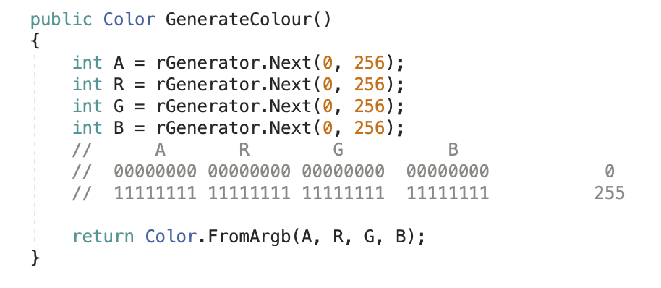
Figure 1.2 A method for generating a colour
The GenerateColour method is used to randomly generate colours. It makes use of a Random number generator object (rGenerator) which has been declared static in another section of the application. The method generates 4 values in the range 0 to 255, which are then used to create a new Color object using ARGB values. The R value represents the red component of the colour, G represents green and B represents blue. A represents the alpha value, which is used to define the level of opacity of the colour.

3.3 Source code references (if applicable)

If you used code, a query, markup, styling or anything similar from any other author / site, you should list the details here. Even if you modified the original text, you still need to credit the original author. There is no need to list the code (since it may be long), but for each piece of text you use that was originally created by someone else you need to provide the following:

- A heading (sub-section) briefly stating what the code was used for
- A brief description on why the code was used
- Name of at least one page / place in your system in which it is used.
- An APA style reference on where you found the code

Example:

3.3.1 Converting images to byte arrays

Description

In order to save an image in the database it first needs to be converted to a byte array. To display the image on a page it needs to be converted from byte array to image.

Usage

User profile

Reference

rajantawate1 (2009). C# Image to Byte Array and Byte Array to Image Converter Class. Retrieved August 28, 2019, from https://www.codeproject.com/Articles/15460/C-Image-to-Byte-Array-and-Byte-Array-to-Image-Conv

3.4 Problems encountered

This section represents a bit of reflection on your part. Discuss anything in the development of your project which you struggled with. For each problem provide a numbered heading, a description of the problem and how you solved it (eventually). For this section it is fine to write in the first person.

Example:

3.4.1 Creating a WCF web service

I have never created any form of web service before. The coding was simple, but I encountered issues while trying to host the web service in IIS.

Eventually I discovered that the folder in which the service was hosted did not have adequate rights on the server. Once I applied the appropriate rights, the service started immediately.

4. Conclusion

Use this section to conclude your study / project. It should be at least half a page in length, but no longer than two. Touch on what the project set out to do, what the study accomplished and any insights you might have gained or ways you want to improve / expand upon the project in future.

References

Add your references here for your entire combined document.

Author, M. (2022). The title here. Overall containing structure here. Publisher.

A. Business case revisions

This document reports on the changes made to the business case, after assessment.

A.1 Changes made in response to comments

A.1.1 Justify (align) document text

Applied text justification to the document.

A.2 Changes made as the project progressed

A.2.1 Changed objectives

The original objective of X no longer described what my study focused on, so I changed it to Y.

B. System requirements, specifications and technical design revisions

This document reports on the changes made to the business case, after assessment.

B.1 Changes made in response to comments

B.1.1 Changes to ERD

To address the comments on the ERD, I made the following changes…

B.2 Changes made as the project progressed

B.2.1 Extra feature added

To add to the scope of my project I added feature X, to provide….

C. Implementation revisions

This document reports on the changes made to the business case, after assessment.

C.1 Changes made in response to comments

C.1.1 Extract of complex code was boilerplate

Replaced this piece of complex code with one I had written. See section 3.?

C.2 Changes made as the project progressed

C.2.1 Added a problem encountered

As I was finishing up my project, I encountered another problem: X. I added this as section 3.?

